Pewaukee School District Educator Effectiveness Plan QUICK SHEET
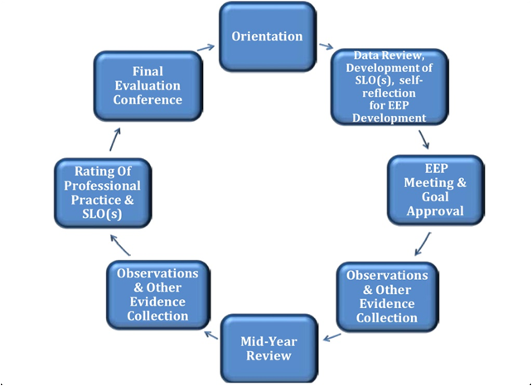
2013-14 EE Timeline for Year Long Courses
August 28 - All teachers will receive training in the Teacher Effectiveness Model and SLO/PPG Creation
from District Office

Sept. 15 - All teachers will have completed a sample SLO/PPG and obtained peer feedback
Note: All teachers will develop 1 SLO & 1 PPG; ONLY teachers involved in the full pilot will develop 2 PPGs and 2 SLOs

Sept. 20- PHS Department action plans due

Sept. 30 - All teachers will gather and analyze baseline data and use this baseline data to refine and make
the SLO/PPG more focused

Oct. 17 (PD Day) - All teachers will analyze baseline data and make final revisions to their SLO/PPG

Oct. 17-Oct. 31- Teachers will schedule a meeting with their supervisor for SLO/PPG (EEP form) approval

Oct. 31 - Deadline for all teachers to have conferenced with their supervisor for approval of their SLO/PPG
(APPENDIX E: pg. 61-62 of Teacher Process Manual)

Feb. 20- Deadline for all teachers to have conferenced with their supervisor for the mid-year goal reflection
and submission of the mid-year goal review form (APPENDIX I: pg.66 of the Teacher Process Manual)

May 5-May 30- Teachers schedule meeting with supervisor for end of year goal review & SLO scoring

May 30- Deadline for all teachers to have conferenced with their supervisors and have completed the end of
year goal review form; Supervisors will score SLO (APPENDIX K & L: pg. 71-72 of the Teacher Process Manual)

2013-14 EE Timeline for Semester Long Courses
August 28 - All teachers will receive training in the Teacher Effectiveness Model and SLO/PPG Creation
from District Office

Sept. 15 - All teachers will have completed a sample SLO/PPG and obtained peer feedback
Note: All teachers will develop 1 SLO & 1 PPG; ONLY teachers involved in the full pilot will develop 2 PPGs and 2 SLOs

Sept. 30 - All teachers will gather and analyze baseline data and use this baseline data to refine and make
the SLO/PPG more focused

Oct. 17 (PD Day) - All teachers will analyze baseline data and make final revisions to their SLO/PPG

Oct. 17-Oct. 31- Teachers will schedule a meeting with their supervisor for SLO/PPG (EEP form) approval

Oct. 31 - Deadline for teachers to have conferenced with their supervisor for approval of their SLO/PPG
(APPENDIX E: pg. 61-62 of Teacher Process Manual)

Dec. 13- Deadline for teachers to have conferenced with their supervisor for the mid-year goal reflection and
submission of the mid-year goal review form (APPENDIX I: pg. 66 of the Teacher Process Manual)

Jan. 2- Jan. 31- Teachers schedule meeting with supervisor for end of year goal review & SLO scoring

Jan. 31- Deadline for teachers to have conferenced with their supervisors and have completed the end of
year goal review form; Supervisors will score SLO (APPENDIX K, J, & L: pg. 71-72 of the Teacher Process Manual)

**Explanations of each Educator Effectiveness process can be found in the DPI WI Educator Effectiveness Teacher Evaluation Process Manual. Forms will eventually be able to be completed in Teachscape, along with any evidence that meet domains of the Framework for Teaching

Resources
School Learning Objectives: (School Improvement Plan)
Principal Educator Effectiveness Plan:

SLO Toolkit
SLO Resources & Example Repository

Teacher Evaluation: Danielson Framework
Formal Observation Pre-Conference Form
Formal Observation Post-Conference Form

School & Student Learning Objectives (SLO) Guiding Questions:
- What source(s) of data was used to identify areas of improvement?
- Which academic area(s) and/or standard(s) is/are being targeted for growth and improvement?
- Which student group is being targeted for academic growth and improvement?
- What is the timeframe for this SLO? (typically will be a year- explain if other)
- What assessment(s) or other evidence sources will be used to measure whether students met the objective? Why is this assessment the best evidence for determining whether students met the objective?
- What is the target level of growth for students? Are all students expected to make the same growth? Why/why not? (to be answered after baseline data is collected)

Professional Practice Goals (PPG) Guiding Questions:
- What instructional method(s) will you use to help students meet the academic goal(s) in your SLO?
- Which domain components does your instructional method(s) correspond to within the Framework
- for Teaching? What professional development and/or resources will you need to help your students meet the academic goal(s) in your SLO?
- What will you need to do differently with the targeted population to help students meet the academic goal(s) in your SLO?

Acronym Glossary
EEP: Educator Effectiveness Plan: A document that lists the Student Learning Objectives, Professional Practice goals and Professional Growth Strategies and Support for an educator, along with the activities required to attain these goals and the measures necessary to evaluate the progress made on them.

PPG: Professional Practice Goals: Establishing practice related goals are an important part of professional practice. Goals are set as educators prepare for their Educator Effectiveness Plans and they are monitored by the educator along with their evaluator during the year.

SLO: Student Learning Objectives: Rigorous, yet attainable goals for student learning growth aligned to appropriate standards set by individual educators. Educators must develop SLOs based on a thorough review of needs, identification of the targeted population, clear rationale for the amount of expected growth, and the identification of specific instructional strategies or supports that will allow the attainment of the growth goals. The ultimate goal of SLOs is to promote student learning and achievement while providing for pedagogical growth, reflection, and innovation.

