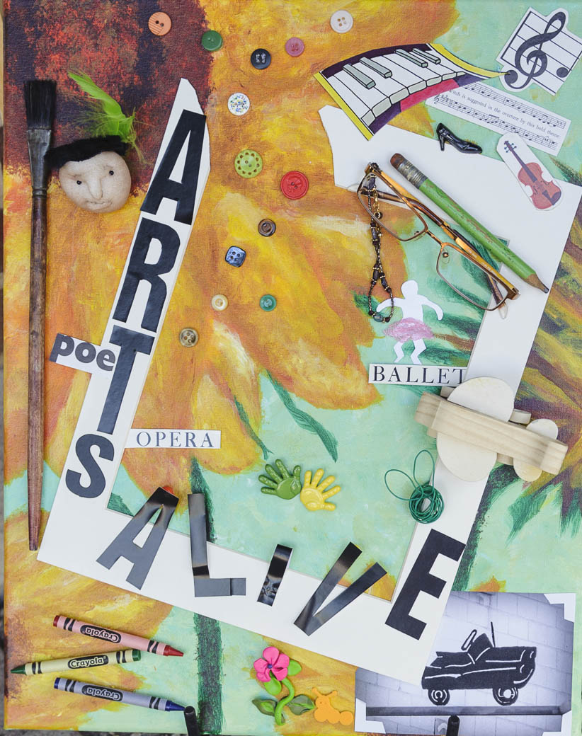
Down  1. 'Waterlillies' impressionist, Claude _________  2. Swing dance style popularized in “Saturday Night Fever”  5. Five lined poem, syllable count 8-8-5-5-8  6. In the Potawatomi language means “Lake of Shells”  8. Entertainment for amateurs to sing lyrics on a video screen  10. Baroque Dutch painter, also toothpaste  11. DaVinci's famous smile  16. Male singer whose nickname is “the boss”  18. Dance style including waltz & tango  20. Early sculptor, later a ninja turtle  21. Twentieth century surrealist painter, Salvador ______  25. Aka “the act of painting outdoors ” and a contest by PAAC at the Pewaukee Waterfront Art Fair  26. Key creative tool of the photographer  27. Box of colored wax sticks  30. Repetition of sounds at the beginning of words  33. Victoria Beckham sang in this girl group  34. Music genre that originated in Jamaica  35. Key medium of a potter  36. Their bass guitarist is Gene Simmons  41. The term for skin art  The first annual ARTs Alive! Crossword Puzzle winner will be drawn from all entries at 6:30 p.m. on Monday, October 12, at the Pewaukee Public Library, as part of a free Open Microphone event. Winner does not need to be present.  You will not receive a confirmation on your entry. A completed puzzle with answers can be found on the PAAC website after Sept. 19, or send a SASE to PAAC for a copy of the answers.  Pewaukee Area Arts Council is a nonprofit 501(c)3 organization formed in 2004 to promote and encourage quality art experiences, programs, events and cultural opportunities in the greater Pewaukee Area. PAAC meets September through June, the second Monday of the month at 5:30 pm at the Pewaukee Library. | 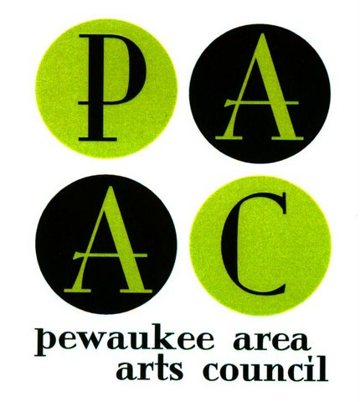  ARTs Alive!  Submit by September 19, 2015  CROSSWORD PUZZLE CONTEST  How do I enter?  FREE  Enter to win prizes including  Artisan179 and Five O’Clock Club gift cards  Get out your lucky pencil and complete the arts-themed crossword puzzle created by the Pewaukee Area Arts Council. (Also available online at PewaukeeArts.org.) Return one game with your name, phone # (and email optional). Postmark by midnight, Saturday, September 19 2015, to: PAAC Crossword Puzzle, PO Box 221, Pewaukee, WI 53072.  You may also drop off your crossword puzzle entry at select businesses in downtown Pewaukee, look for ARTs Alive! Sign in the window. Your entry does not have to be correct. You do not need to be present to win at the drawing. One per person.  Be creative. Be a part of the first annual ARTs Alive! coordinated by the Pewaukee Area Arts Council.  Join the many pop-up artistic happenings from Sept. 10 to 19, 2015 in Pewaukee. Schedule of ARTs Alive! events at PewaukeeArts.org. More information on back page.  PewaukeeArts@gmail.com (262) 725-1468

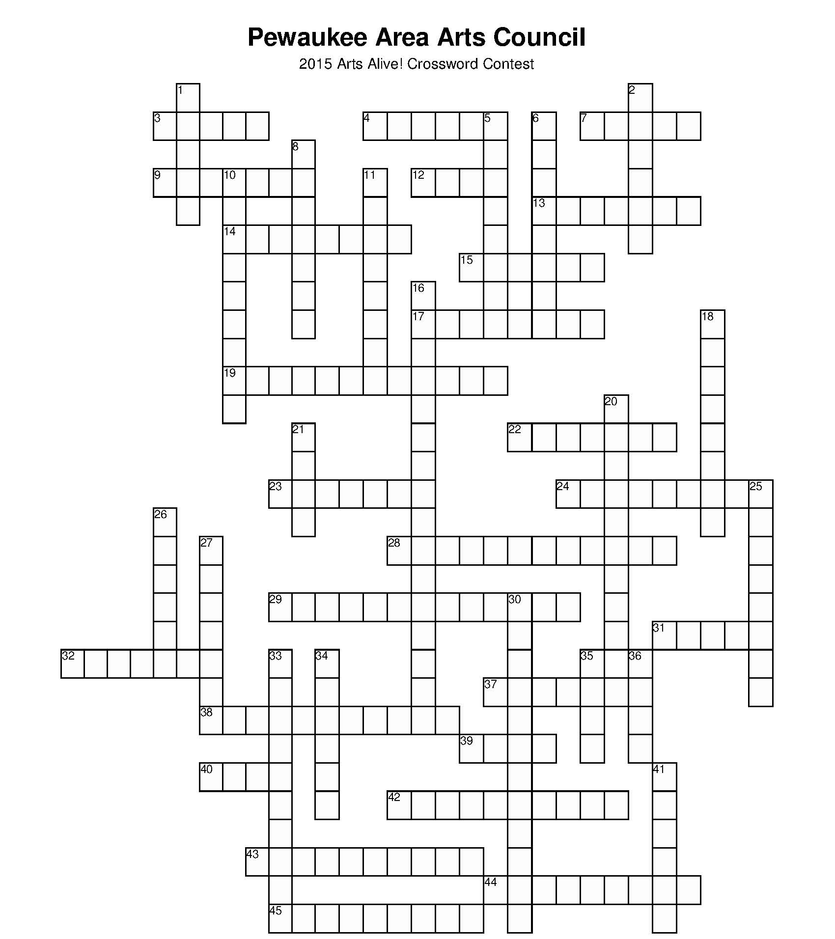

Name _____________________________________________
Phone #___________________________________________
Email______________________________________________
Across
3. C.M. Coolidge painted 'Dogs playing ________'
4. 15 min of 'Campbell's Soup Can' fame
7. Instrument played by one-armed member of Def Leppard
9. Twentieth century American female painter ____ O'Keeffe
12. Medium used prior to digital photography
13. Recited an original poem at Bill Clinton’s 1993 inauguration, Maya __________
14. Popular group wedding dance to a song by Los del Rio
15. Upcoming musical bus trip by PAAC in Nov. 2015 (think OZ)
17. Saturday Evening Post artist
19. Iconic movie starring Patrick Swayze and Jennifer Grey
22. American paint splatter artist, Jackson __________
23. Tiny metal squares that sparkle
24. “Messy” community art project that started PAAC non-profit in 2004; is displayed in the Pewaukee Library stairwell
28. A word that sounds like the noise it describes
29. PAAC’s biennial event, showcases a variety of student art
31. The “first” ballerina; she dances the leading roles
32. A female voice of the higher range, also a hit HBO series
37. Composer aka the “Red Priest”
38. Annual fundraiser, fashions & arts show by PAAC
39. An artist who writes often rhyming
40. Sticky white stuff
42. Term for more than one artistic expression inspired by another. (ie. poem inspired by a painting)
43. Dance movements such as spins, freezes & poses
44. A person who directs the orchestra
45. Physical work of stone, bronze, clay, etc.

Thank you Silverado Memory Care, Brookfield, for printing support.

