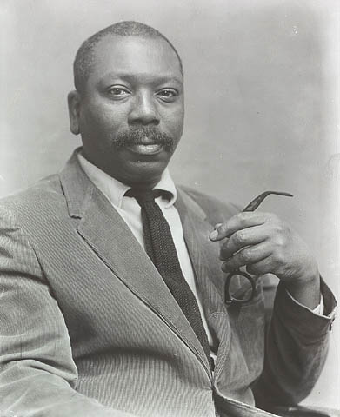

_________________________

_________________________

**My wall:**

**Friends:**

**Important bio information:**

**How to identify my work:**

**Themes in my work:**

Name:

Jacob Lawrence

Dates:

Country of origin:

Country or countries where I worked:

**Groups (period, movement, school):**

**About Me:**

**ArtistBook home account privacy logout**