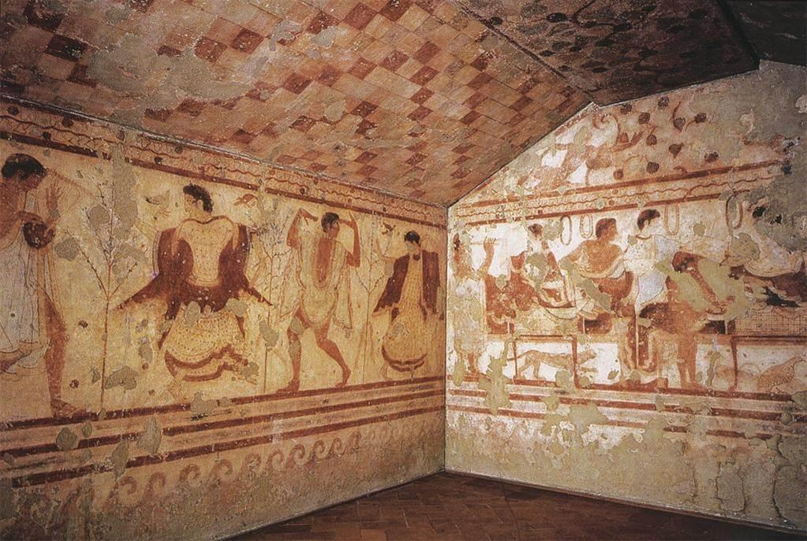

**4. CONTENT:** (subject & genre, iconography, symbolism, the story)

**5. ORIGINAL CONTEXT/ SITE/ INTENDED FUNCTION OF THE WORK:** (Overlap to #6)

**6. INTENDED PURPOSE & MOTIVATION** (why was it made?); **PATRONAGE/AUDIENCE** (who was it made for?); **ARTIST’S DECISION MAKING:**

**8. THEME(S):**

**COMPARE TO ANOTHER WORK(S):**

**7. INNOVATION/ CHANGE(S):**

**CONVENTION/ TRADITION(S):**

**3. MATERIALS AND TECHNIQUE:** (art making processes)

**2. FORM:** (use of design elements/principles: color, shape, value, texture, line, space; balance, contrast, emphasis, movement, etc.)

**1. IDENTIFICATION:** (Artist, title, date, size, country of origin, period/style)

Tomb of the Triclinium

Artist unknown

480-470 B.C.E.

Tarquinia, Italy

Archaic Etruscan

Tufa and fresco