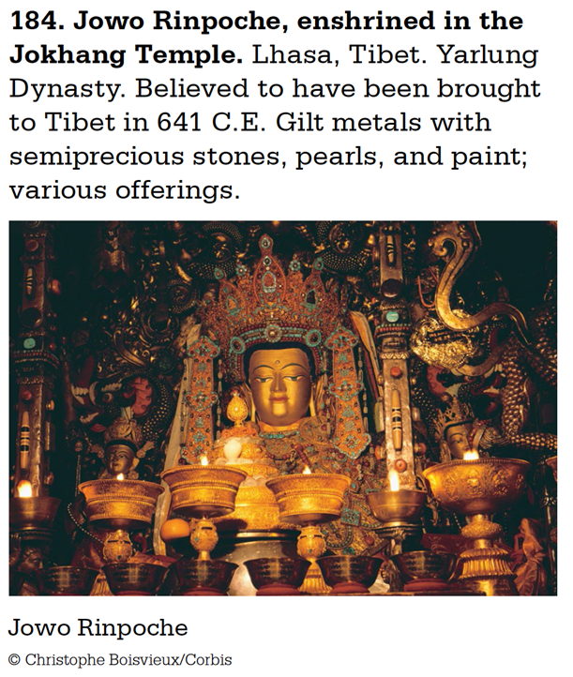

**4. CONTENT:** (subject & genre, iconography, symbolism, the story)

**5. ORIGINAL CONTEXT/ SITE/ INTENDED FUNCTION OF THE WORK:** (Overlap to #6)

**6. INTENDED PURPOSE & MOTIVATION** (why was it made?); **PATRONAGE/AUDIENCE** (who was it made for?); **ARTIST’S DECISION MAKING:**

**8. THEME(S):**

**COMPARE TO ANOTHER WORK(S):**

**7. INNOVATION/ CHANGE(S):**

**CONVENTION/ TRADITION(S):**

**3. MATERIALS AND TECHNIQUE:** (art making processes)

**2. FORM:** (use of design elements/principles: color, shape, value, texture, line, space; balance, contrast, emphasis, movement, etc.)

**1. IDENTIFICATION:** (Artist, title, date, size, country of origin, period/style)

Jowo Rinpoche, enshrined in the Jokhang Temple

Vishakarma (emanation of the Buddha himself)

Believed to have been brought to Tibet in 641 C.E

8’ high (approximately)

Lhasa, Tibet

Buddhist, Yarlung Dynasty

Gilt metals with semiprecious stones, pearls, and paint; various offerings